CST 415 – Lecture 6
Wilsonville, Fall 2017

HTTP part 2, HTTPS, SSL/TLS

HTTP (cont’d)
Thanks to Wikipedia (the font of all wisdom and knowledge) for the following…

HTTP Authentication
https://en.wikipedia.org/wiki/Digest_access_authentication#Example_with_explanation
Uses headers “WWW-Authenticate” and “Authorization”
Not a very strong authentication scheme

Request Methods supported in HTTP/1.1
https://en.wikipedia.org/wiki/Hypertext_Transfer_Protocol#Request_methods
GET – retrieve a representation of the resource
HEAD – retrieve header that would be returned with a GET for the resource (no content)
POST – request server to receive data as a “subordinate” of the resource
PUT – request server to store the data as the identified resource
DELETE – request server to delete the resource
TRACE – echo the request to help debug what intermediate servers did to it
OPTIONS – request server to identify which methods are supported for a resource
CONNECT – convert the request into a TCP/IP tunnel throuh a proxy
PATH – partially modify resource with given data

Header Fields
https://en.wikipedia.org/wiki/List_of_HTTP_header_fields
Many, many fields available for requests and responses

Status Codes
https://en.wikipedia.org/wiki/List_of_HTTP_status_codes
1xx – Informational responses
2xx – Success
3xx – Redirection
4xx – Client errors
5xx – Server errors

Pete’s favorite client error code:
420 Enhance Your Calm (Twitter)
Returned by version 1 of the Twitter Search and Trends API when the client is being rate limited; versions 1.1 and later use the 429 Too Many Requests response code instead.^{[73]}

Could be useful in today’s climate of Tweet-storms (just sayin’)

Redirection
https://en.wikipedia.org/wiki/URL_redirection
Redirecting browser to a different URL for a resource
Useful for many purposes, most commonly to cause a browser to go to a different page
3xx responses are used along with the “Location” header, e.g.
HTTP/1.1 301 Moved Permanently
Location: http://www.example.org/

REST and RESTful API’s
https://en.wikipedia.org/wiki/Representational_state_transfer
Application architecture based on web technologies and HTTP

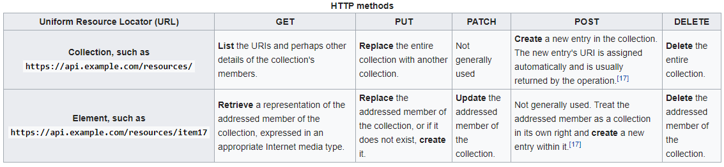

Caching
https://en.wikipedia.org/wiki/Web_cache
Web content can be cached (stored) in various places to improve performance/scalability
Client-side – Resources available to browser, e.g. when back butotn is used
Server-side – Pre-computed and stored data on server, e.g. frequent query to DB

Cache Control:
Freshness – Reuse previous response, uses Expires or Cache-Control headers
Validation – Check changes, uses Last-Modified and If-Modified-Since headers
Invalidation – POST/PUT/DELETE query invalidates cached resources

Proxy Servers
https://en.wikipedia.org/wiki/Proxy_server
Sit between clients and servers, providing some service for either or both
Open Proxy – Forwards requests for clients to preserve anonymity
Reverse Proxy – Serves as entry point to a network of servers
Uses of Proxies:
Encryption – Client to Proxy is encrypted, Proxy to Web Server is open
Load balancing – Requests forwarded to a pool of servers
Caching – Serves static responses to frequent requests
Compression – Compresses responses to clients on server’s behalf
Security – Authentication, tracing, filtering, analyzing, blocking, etc…

Firewalls
https://en.wikipedia.org/wiki/Firewall_(computing)
Provides layers of security to a network by intercepting traffic in/out of a local network
Network Layer – Block based on addresses, ports, and packet contents
Application Layer – Applies rules to protocol and content across packets

What kind of, and how would a, firewall would catch…
- Trojan horse’s attempt to allow FTP’ing database files off a server?
- Phishing email attack to get a user to download a trojan horse?
- Insider’s attempt to send employee SSNs to a hacker?

Load Balancing
https://en.wikipedia.org/wiki/Load_balancing_(computing)
Server-side load balancers distribute connections or requests to multiple servers

When a request is received at the load balancer…
- Determines which pool of servers the request should go to
- Identifies a specific server
- Forwards the request and returns the response (like a proxy)

Must handle the following challenging situations:
- Server session – Server needs access to session data, or lose session context
- Server-side caching – Server needs the cached data, or loses caching benefits
- Encrypted sessions – Server must have access to the session key

Load balancer may be the end-point for encryption, to avoid sharing keys across LAN

Typically load balancers solve these by being aware of sessions…
Sticky sessions – Load balancer sends requests to same server after connection establish
Session and Cache servers – Offload session state and cache from individual web servers

Performance monitoring and auto-scaling can be hooked into load balancers
If a server stops responding correctly, it can be removed from the pool
If the pool’s response is diminishing, more resources can be added
If the pool’s capacity is not being fully used, resources can be subtracted

Warning: The load balancer itself should not be a single point of failure!

MIME or Media Types
https://en.wikipedia.org/wiki/Media_type

MIME – Multipurpose Internet Mail Extensions
Standard, well known, list of document types based on email attachments
Allows the browser to determie how to interpret the content and render it

Used in the “Content-Type” header field

Format is typically… type/sub-type

Interesting Examples:
application/javascript
application/json
application/xml
application/zip
application/pdf
text/css
text/html
text/csv
text/plain
image/jpeg
image/gif (jif)

Dynamic Content and Web Applications
Initial implementations of the web focused on static content (HTML, images, etc.)
Quickly designers recognized the need for dynamic content…
Response content generated on the fly, depending on the request parameters

This gave rise to an amazing variety of technologies
Web servers today are viewed as platforms for hosting the software that generates content

CGI – Common Gateway Interface (1993)
https://en.wikipedia.org/wiki/Common_Gateway_Interface
One of the first attempts to standardize how to write code that creates dynamic content

Defined variables to be used in request/reponse between the web server and a cgi “script”
The web server uses the requested URL to identify which script to run

For a GET, the URL’s parameters (specified after the ?) are passed to the script
For a POST, the request’s content document is passed to the script, containing form data
The script creates a response and sends it back to the server and from there to the client

CGI provides a very simple, flexible interface and is supported on all web servers
Typically it results in a new process for each script invocation, which can be expensive!

HTML Forms (1995)
https://en.wikipedia.org/wiki/Form_(HTML)
Forms were a feature of HTML almost from the very beginning of the standard
Provide tags for creating simple UI elements embedded in web pages
Each UI element’s data is sent to the server with a POST request
Used in conjunction with CGI, web applications were born

<html>
<body>
<p>Enter your user name and password:</p>
<form action="http://a.web.site/form_handler" method="POST">
User Name: <input name="UserName" type="text" />
Password: <input name="Password" type="text" />
<input type="submit" value="Submit" /></form>
</body>
</html>

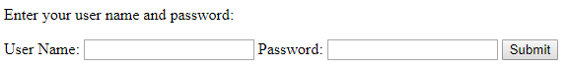

JavaScript (1995)
https://en.wikipedia.org/wiki/JavaScript
Interpreted scripting language, event driven and object oriented, similar to Java’s syntax
Weakly typed, very flexible and extensible

First used in early browsers to provide some dynamic, client-side behavior to web pages
Frequently used for validation of user input in web forms

Over the years, has become the most common client-side language
Many libraries are available for creating dynamic web pages

Java Applet (1995)
https://en.wikipedia.org/wiki/Java_applet
Small Java applications that run on the browser, embedded in HTML pages
Provided the ability to run client side code that was meant to be browser-agnostic

ActiveX (1996)
https://en.wikipedia.org/wiki/ActiveX
Microsoft’s answer to Java Applets, using COM for interoperability
Only supported on Windows and optimized for Internet Explorer (IE)

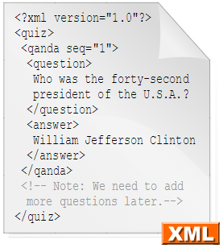
XML – Extensible Markup Language (1996)
https://en.wikipedia.org/wiki/XML
Language for expressing data in a form that is easily read by machines and humans

Structured hierarchically, using tags, attributes and elements

Quickly became the defacto standard for data exchange on the internet, but eventually fell out of favor, and is largely replaced by JSON, due to its verbosity

CSS – Cascading Style Sheets (1996)
https://en.wikipedia.org/wiki/Cascading_Style_Sheets
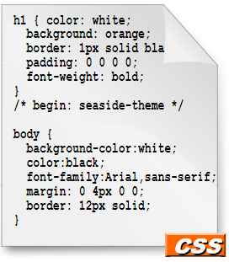
Created to facilitate separating presentation from content

Style sheets describe how to present the data based on types of content

One css file can be applied to many HTML documents
Changing one file can then change the look of many pages

AJAX – Asynchronous JavaScript and XML (1999)
https://en.wikipedia.org/wiki/Ajax_(programming)
Technique for minimizing full page requests in HTML/form based web applications
JavaScript embedded in a page opens a socket to the server to exchange data, e.g.…
var xhr = new XMLHttpRequest();
xhr.open('get', 'send-ajax-data.php');

This request opens a persistent connection through which simple request/responses are sent with just changes to data. JavaScript event handlers update the page dynamically.

Java EE – Java Platform, Enterprise Edition (1999)
https://en.wikipedia.org/wiki/Java_Platform,_Enterprise_Edition
Based on Java’s run-time and Java Beans
Defined server side objects, called Servlets, that process requests and produce responses
JSP, Java Server Pages, added server side code to HTML pages
JSP is requested in the URL
URL query parameters and POSTed form data made available to Java
JSP parsed and embedded Java code executed to create dynamic portions of page
Resulting HTML page downloaded to client
Provides access to entire Java platform for server side code
Opened up the space of “web applications”
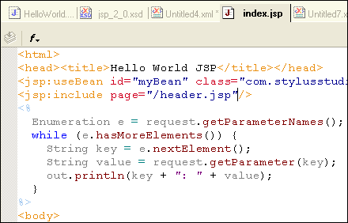

XSL – Extensible Stylesheet Language (2001)
https://en.wikipedia.org/wiki/XSL
Language for specifying how to apply “style” to an XML document
XSL-T, XSL Trasform, language for transforming an XML document into HTML
Alternative to server code embedded in HTML pages
Servlet creates XML document, chooses XSL-T document
XML + XSL-T = HTML… sent in response to browser
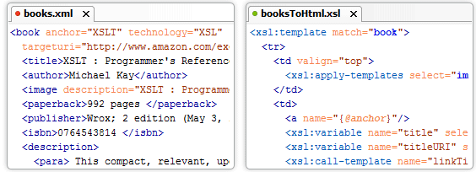

JSON – JavaScript Object Notation (2001)
https://en.wikipedia.org/wiki/JSON
Flexible format for describing hierarchical, object data, machine and human readable
Plays a role similar to XML, but much less verbose
Simple JavaScript libraries for creating/parsing JSON data, e.g.
var p = JSON.parse(json_string);

Example JSON file:
{
"firstName": "John",
"lastName": "Smith",
"address": {
"streetAddress": "21 2nd Street",
"city": "New York",
"state": "NY",
"postalCode": "10021-3100"
},
"phoneNumbers": [
{
"type": "home",
"number": "212 555-1234"
},
{
"type": "mobile",
"number": "123 456-7890"
}
],
}

HTML 5 (2014)
https://en.wikipedia.org/wiki/HTML5
The 5th standard verison of HTML, includes many dynamic features natively
The <canvas> tag creates an area in a page that can be drawn on by embedded script
Many libraries have been created that take advantage of canvases to draw UI elements
Just google “html canvas libraries”
Here’s an example…
https://www.slant.co/topics/28/~best-javascript-drawing-libraries

HTTPS – HTTP Secure
https://en.wikipedia.org/wiki/HTTPS
Enhanced protocol to include authentication and communication confidentiality
First introduced in 1994 for Netscape, became a full standard in 2000

Authentication of server, and optionally client, using X.509 public key certificates
Session key is created encryption of all subsequent connections for that session

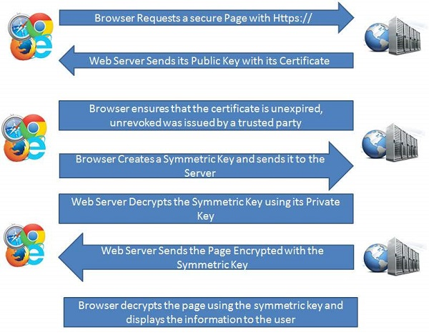

HTTPS uses SSL or TLS for session security
https://en.wikipedia.org/wiki/Transport_Layer_Security
https://msdn.microsoft.com/en-us/library/cc767139.aspx
SSL – Secure Socket Layer
TLS – Transport Layer Security

Handshake Protcol:
Used to negotiate authentication and encryption over the top of a TCP socket

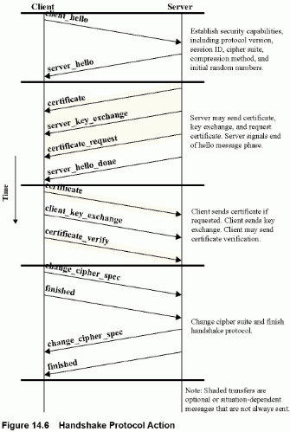

Record Protocol:
Used to encrypt request/response data over a TCP socket after handshake

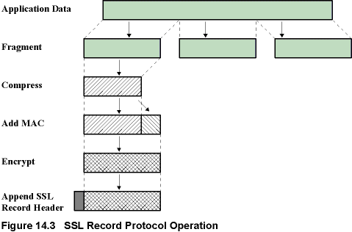

SSL Header includes…
- Content Type (8 bits): The higher-layer protocol used to process the enclosed fragment.
- Major Version (8 bits): Indicates major version of SSL in use. For SSLv3, the value is 3.
- Minor Version (8 bits): Indicates minor version in use. For SSLv3, the value is 0.
- Compressed length (16 bits): The length in bytes of the plaintext fragment (or compressed fragment if compression is used).

